# Power kabel splitten

# Splicing and Soldering

The main benefit to this cable is that it requires less space and the resulting cable is simpler than using terminal blocks. It is crucial that any soldering be performed by an expert to maximize the structural integrity of the custom cable. Refer to the IPC/WHMA-A-620C Standard to ensure that the quality of the soldering connection is sufficient.

Figure 9. Wiring diagram for the terminal block solution to split power between TM and LD from the LD's Battery

## Parts List

|  |  |  |
| --- | --- | --- |
|  | Quantity | Description |
|  | 3 | <=8 AWG Wire (Colored for battery +) and >=8" Length |
|  | 3 | <=8 AWG Wire (Colored for battery -) and >=8" Length |
|  | 1 | <=12 AWG Wire (Colored for charging voltage) and > =8” Length |
|  | 2 | Molex female plug, manufacturer part#0428180312 |
|  | 2 | Molex male plug, manufacturer part#0428160312 |
| Afbeelding met gereedschap  Beschrijving automatisch gegenereerd met gemiddelde betrouwbaarheid | 5 | Male crimp pins, manufacturer part#0428170032 |
|  | 5 | Female crimp pins, manufacturer part#0428150032 |

Table 2. Components needed to assemble power splitter

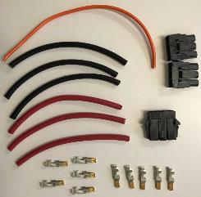

Figure 10. Components needed to assemble power splitter

## Assembly Instructions

The Molex crimper with Molex part ID 0640160170 can be used to connect these 8 AWG crimp pins.

##### **Part 1:** Connecting to the core

Assemble one of each color wire and the charging wire into a male Molex plug with female crimp pins. Put voltage into position 1, charging voltage into position 2 and ground into position 3.

*Note: the Molex plug are numbered on the tab used to lock the crimp pins in place.*

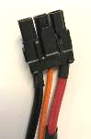

Figure 10. The Molex plug which connects to the LD core

##### **Part 2:** Connecting to the battery

Assemble a new ground wire and a new voltage wire into a female Molex plug with male crimp pins with the voltage wire in position 1 and the ground wire in position 3. Then add the other end of the charging wire from part 1 into the middle of the Molex plug in position 2.

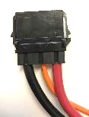

Figure 11. The Molex plug which connects to the battery

##### **Part 3:** Connecting to the TM

Assemble the last ground and voltage 8 AWG wires into a female Molex plug with female crimp pins. Put voltage into position 1 and ground into position 3.

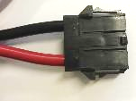

Figure 12. The Molex plug which connects to the TM controller

Then, add a male Molex plug with male crimp pins to the cable that comes with the TM robot. Attach the TM’s voltage input wire into position 1 and the ground input wire into position 3.

Finally, solder the loose voltage wires together and then solder the loose ground wires together and add heat shrink tubing to achieve a cable similar to in the image below.

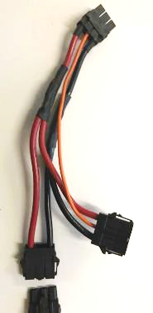

The TM power cable with added Molex Male Plug

Connects to the battery cable (Female Plug)

Connects to the TM power cable (Female Plug)

Connects to the LD core (Male Plug)

Figure 13. The completed split power cable using the wire splice method. The connector on the right is a male Molex plug attached to the TM power input wire which comes with the mobile version of the TM robot.

To install the new cable on the LD underneath the core guard, some modification needs to be made to the guard that prevents access to the lower portions of the LD core. First, remove the guard completely by removing the two screws that hold it in place.

*Figure 14, Figure15,* and *Figure 16* show how the custom cable can be installed. A hole can be drilled into the panel used to guard the bottom half of the core, and a rubber grommet can be used to guide the cable to above the panel. If a grommet is used, then the connector must be assembled after putting the wires through the hole. However this is not a problem if you assemble the cable prior to putting it through the guard because these Molex plugs can easily be disassembled and reassembled without a tool.

***Note:*** The hole should be positioned in a location which minimizes any bend or strain on the power cable. For safe usage, the 8 AWG wires should not bend at a radius less than 40 millimeters. Furthermore, the loss of material due to the drilled hole should not negatively impact the integrity of the guard.

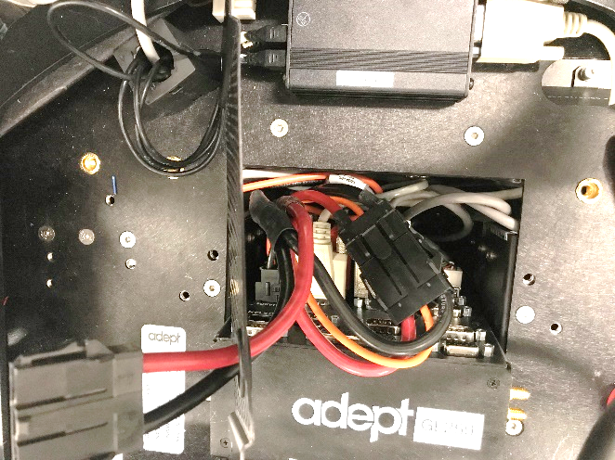

Figure 14. Inside of the core bay when using the custom power splitting cable with the guard removed.

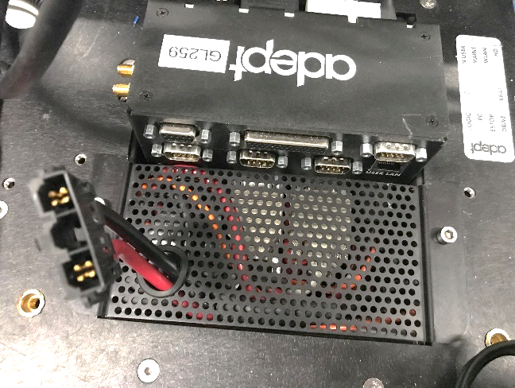

Figure 15. The core bay with the battery voltage exposed through a female connector through a hole in the guard

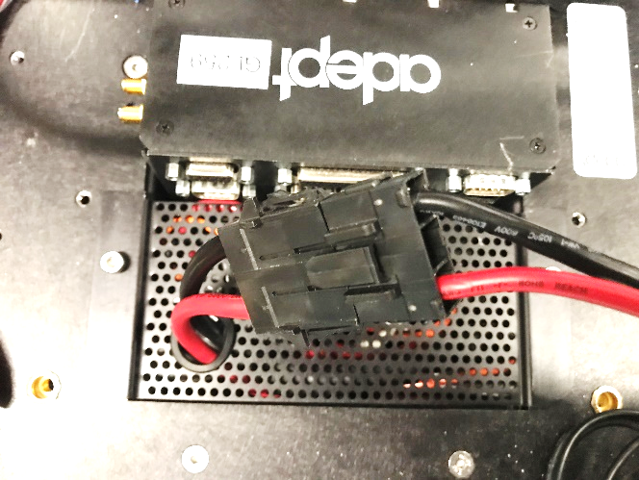

Figure 16. The core bay with the TM connected to the custom power cable